CMake

Conteúdo

Cmake 2
Download 2
Install 2
Livro: Mastering CMake 3.1 Edition 2

Cmake
CMake is an open-source, cross-platform family of tools designed to build, test and package software. CMake is used to control the software compilation process using simple platform and compiler independent configuration files, and generate native makefiles and workspaces that can be used in the compiler environment of your choice.

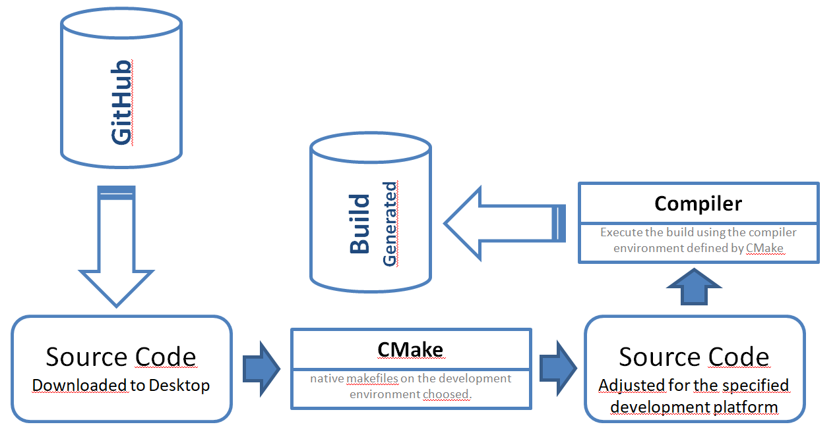

Download
The latest release should be downloaded from: https://cmake.org/download/

Download the current installer for Windows, example: cmake-3.20.1-windows-x86_64.msi

Install
Execute the installations file and make sure that the PATH Will be updated for all users.

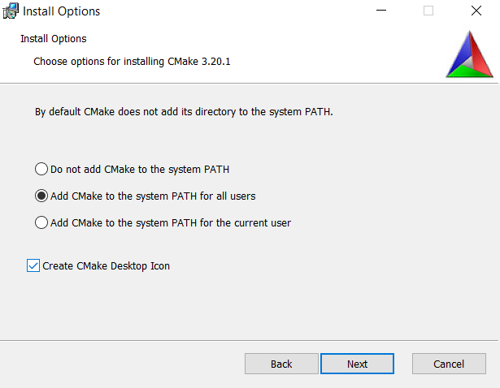

Livro: Mastering CMake 3.1 Edition

